print('{0},{1},{2}'.format('apple','banana','carrot','pen'))

print('{},{},{}'.format('apple','banana','carrot'))

print('{2},{1},{0}'.format('apple','banana','carrot'))

print('{2},{1},{1},{0}'.format('apple','banana','carrot'))

print('{2},{1},{0}'.format(*'abcd'))

print('{0},{1},{0}'.format('apple','banana','carrot'))

print('Coordinates:{latitude},{longitude}'.format(latitude='37.24N',longitude='-115.81W'))

print('Welcome:{name},Your college is: {college}'.format(name='Harsh',college='IMS UC'))

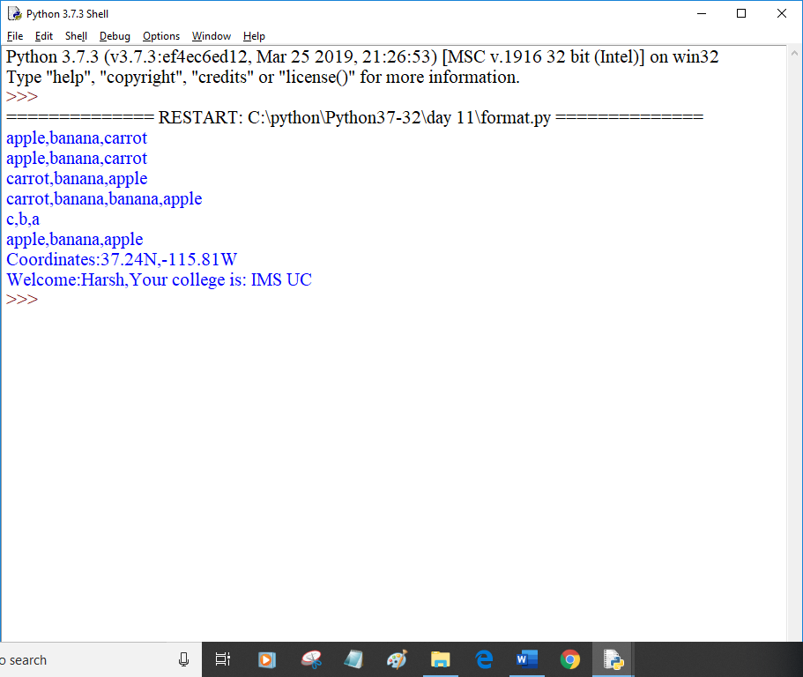

coord={'latitude':'37.24N','longitude':'-115.81W'}

print('Coordinates:{latitude},{longitude}'.format(**coord))

c=3-5j

print('The complex number {0} is formed from the real \

part{0.real} and the imaginary part {0.imag}'.format(c))

coord = (3,5)

abc = (2,9)

print( 'X: {0[0]}; Y: {0[1]}; abc: {1[0]},{1[1]}'.format(coord,abc))

coord = [(3,9),(2,4)]

print('first tuple: {0[0]},{0[1]}, second tuple: {1[0]},{1[1]}'.format(*coord))

print('{:#<30}'.format('Apple'))

print('{:*>30}'.format('Apple'))

print('{:^30}'.format('Apple'))

print('{:*^30}'.format('Apple'))

print("int:{0:d}; hex: {0:x}; oct:{0:o}; bin{0:b}".format(42,55))

print("int:{1:d}; hex: {1:x}; oct:{1:o}; bin{1:b}".format(42,55))

print('{:,}'.format(1234567890))

points = 19.0; total =22

print('Correct answers: {:.4%}'.format(points/total))

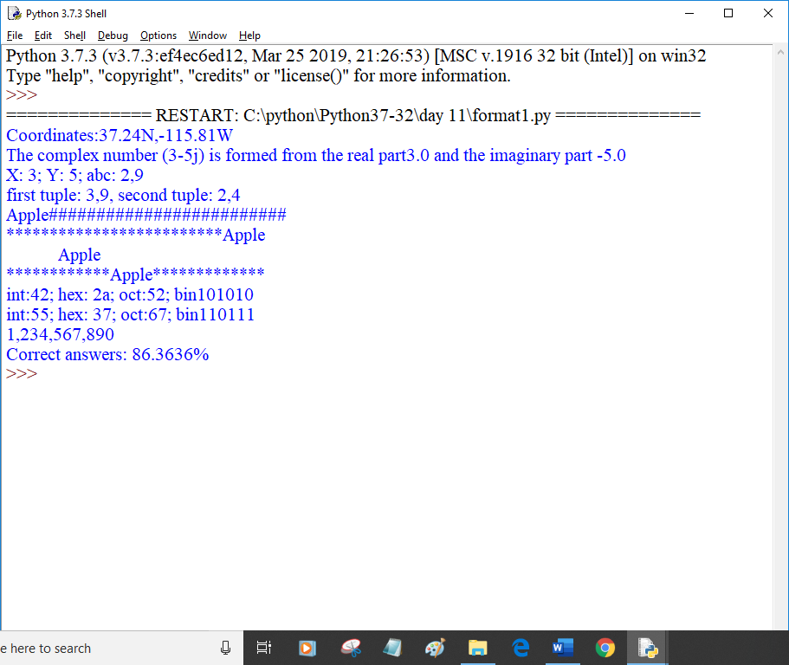

def demo_yield():

print("code segment1 executed")

yield 1

print("code segment2 executed")

yield 2

print("code segment3 executed")

yield 3

print("code segment4 executed")

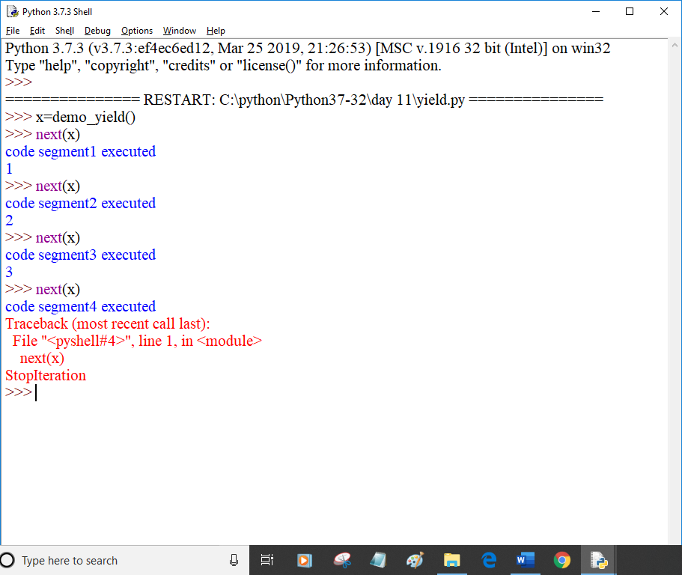

def sum_num(x):

res= 0

for i in range (x+1):

res=res+i

print("i=",i,"res=",res)

yield res

ob=sum_num(10)

for i in range(11):

print(next(ob))

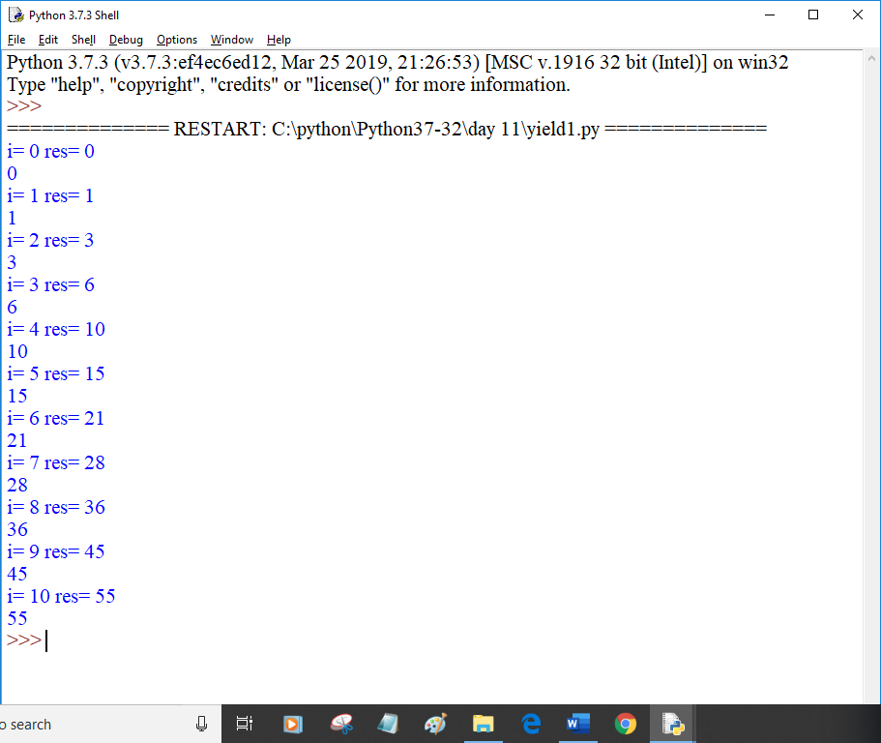

a=7

b=1 if a>=5 else 42

print(b)

status=1

msg="Logout" if status==1 else "Login"

print(msg)

c=1 if 2+2==5 else 2

print(c)

